CONFERENCE HOTEL and RESERVATION INFORMATION
CATA-2018 and BICOB-2018
March 19-21, 2018, Las Vegas, Nevada, USA

The ISCA CATA-2018 and BICOB-2018 will be held at the Flamingo Hotel, Las Vegas, USA.
The Flamingo Las Vegas hotel is a self-contained casino and resort offering everything an adventurous vacationer could want; including a tropical Wildlife Habitat and a 15-acre Caribbean-style water playground, the Go Pool. Set on the famous four corners of Las Vegas Boulevard and Flamingo Road, this Las Vegas hotel combines heart-pounding excitement with hospitality and service that's second to none.
Hotel Address: 3555 Las Vegas Blvd. South, Las Vegas, NV 89109, USA
Hotel Direct Line: (702) 733-3111
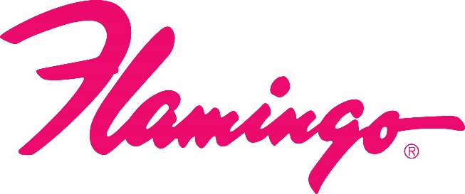
Hotel Website: http://www.flamingolasvegas.com/

ISCA Conference Reservation Information:
The Hotel Reservation CUT-OFF Date is FEBRUARY 10, 2018 and based on room availability, and all reservations must be made before this date to receive the conference discounted room rate. We have arranged a block of rooms at the Hotel. These rooms have been blocked to give a special conference discounted rate of $79.00 Single or Double occupancy per night + Tax and fees. Please make your reservations EARLY in order to guarantee a room.
Reservation for the ISCA Group (CATA-2018 and BICOB-2018) can be made on-line or by Phone. For making the reservation on-line, please use the following Group Reservation WEBLINK:
WEBLINK (no group code needed for online bookings)
https://aws.passkey.com/go/SFSOC8

Reservation by Phone: 1-888-373-9855
While making the reservation by phone, please use the following Group code and Group name to receive the ISCA conference rate.
Group Code: SFSOC8
Group Name: International Society for Computers and Their Applications (ISCA)

